E4S KS1 Feelings and Attitudes - Coping with Feelings and Change

Cornerstone: | RSE
Concept: | Feelings and attitudes
Theme: | Coping with feelings and change
Key Questions: | Teachers have used the questions and statements from the E4S curriculum to plan lessons on being safe, which are delivered throughout the year according to the school’s scheme of work.  This is what your child will be learning about in the upcoming scheme of work:  - How do I know how other people are feeling?  - How do I affect how other people are feeling?  - What do we look like when we feel different ways?  - What can we do to help feel differently?  - What are the things that we treasure and how do we look after them?  - How do we feel when things get lost or ruined?  - How do people behave when that happens?  - How do I feel when things change?  - What can we do to help those who have lost something feel better?
Questions to consider with your child: | What different feelings do you have?  What helps you or makes you feel better when you are feeling sad or worried?  How can you make sure you look after things?  What can you do if you’ve lost something that you treasure?  Who can you ask for help?
Suggested Resources for parents: | Please find additional support and guidance below in relation to coping with feelings and change.  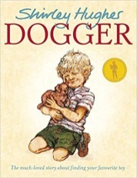  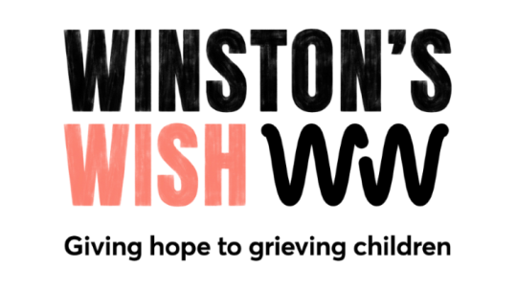  Dogger  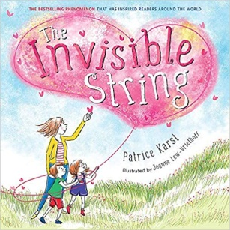  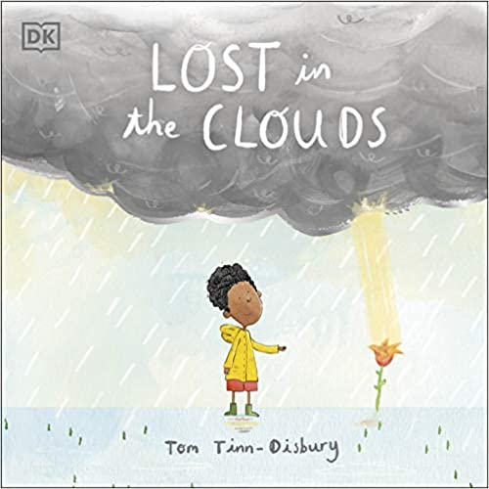  Lost in the Clouds  Young Minds  Winston's Wish  The Invisible String

