E4S Managing time online Parent Input

Cornerstone | DML - Key Stage Two
Concept | Self-image, mental health and wellbeing
Theme | Managing time online
Key Questions | Teachers have used the questions and statements from the E4S curriculum to plan lessons on managing time online, which are delivered throughout the year according to the school’s scheme of work. This is what your child will be learning about in the upcoming scheme of work:  - What might be the negative impact of spending too much time online?  - What are the guidelines regarding screen time? Why is this necessary?  - What could make someone want to spend a lot of time online?
Questions to consider with your child | What do you like most about the internet and why?  How does going online make you feel?  What is good about communicating online? What is good about communicating in person?  What could you do if being online is making you feel worse rather than better?  What are some of the negative consequences if you spend too much time online?  Do you know what a healthy amount of time to spend online is?  Why do you/don’t you spend a lot of time online?
Resources for parents | Childnet: 'Screen Time Advice for parents'  Common Sense Media: 'Managing Screen Time'  Common Sense Media: 'Managing Screen Time During Remote Learning'  Webster’s Bedtime by Hannah Whaley  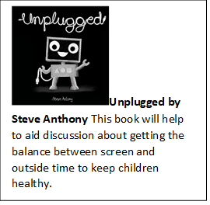Unplugged by Steve Anthony

