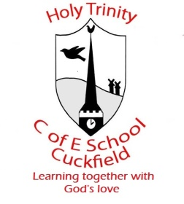 Update from Year 1 for beginning of Week 5

Dear Parents / Carers, Date: 31.1.20
In English, this week we will be focusing on reading and writing some facts about birds we will be researching. We will be sending home over the weekend a bird spotting sheet for the children to record the birds that they can identify. Please send these back into school so we can talk to the children about what they have seen over the weekend. We will be focusing on information facts about blackbirds. If you have any information books on birds in general we would be very grateful for the loan. We will be designing and making bird feeders to feed the birds in winter. These will be placed in our school grounds to feed the birds.
We would be most grateful for any empty yogurt pots that we can use to make our bird feeders and also any donations of bird seed or raisins please. We need them by the end of the day on Monday please.
Here are the sounds and the spellings your children have been learning this week in their Reading Skills lessons:
Spring Week 4
Group | Sounds covered | Spellings
Robots | split digraphs a-e, i-e, o-e, u-e | House 10 – ask, friend, school, put
Bluebirds | ur, er, ow, ai | House 10 – ask, friend, school, put
Scrapheaps | Recap – are, ear, ure, er | House 10 – ask, friend, school, put
Mountains | Review set 3 & set 4 sounds | House 10 – ask, friend, school, put
Ticktocks | All the different ways to make the vowel sound u, plurals s and es, what are verbs | House 10 – ask, friend, school, put

Many thanks
Year One team

