E4S Identities online and offline Parent Input

Cornerstone | DML - Key Stage One
Concept | Self-image, mental health and wellbeing
Theme | Identities online and offline
Key Questions | Teachers have used the questions and statements from the E4S curriculum to plan lessons on activities online and offline, which are delivered throughout the year according to the school’s scheme of work. This is what your child will be learning about in the upcoming scheme of work:  - What activities are classed as being online or using the internet?  - When does spending time online become unhealthy and why?  - How do we see ourselves and others online?  - Do we appear the same online as offline?  - Do people ever pretend to be someone online that they are not really?
Questions to consider with your child | What activities do you do on the internet or online? Why?  Do you communicate with anyone on the internet or online?  What do you like most about the internet and why?  What is good about communicating online? What is good about communicating in person?  What could you do if being online is making you feel worse rather than better?  Do you know what a healthy amount of time to spend online is?  How do you behave online?
Resources for parents | Childnet: 'Screen Time Advice for parents'  Common Sense Media: 'Managing Screen Time'  Webster’s Bedtime by Hannah Whaley  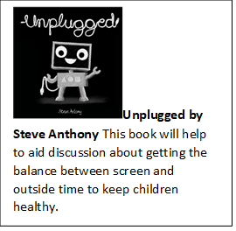Unplugged by Steve Anthony

