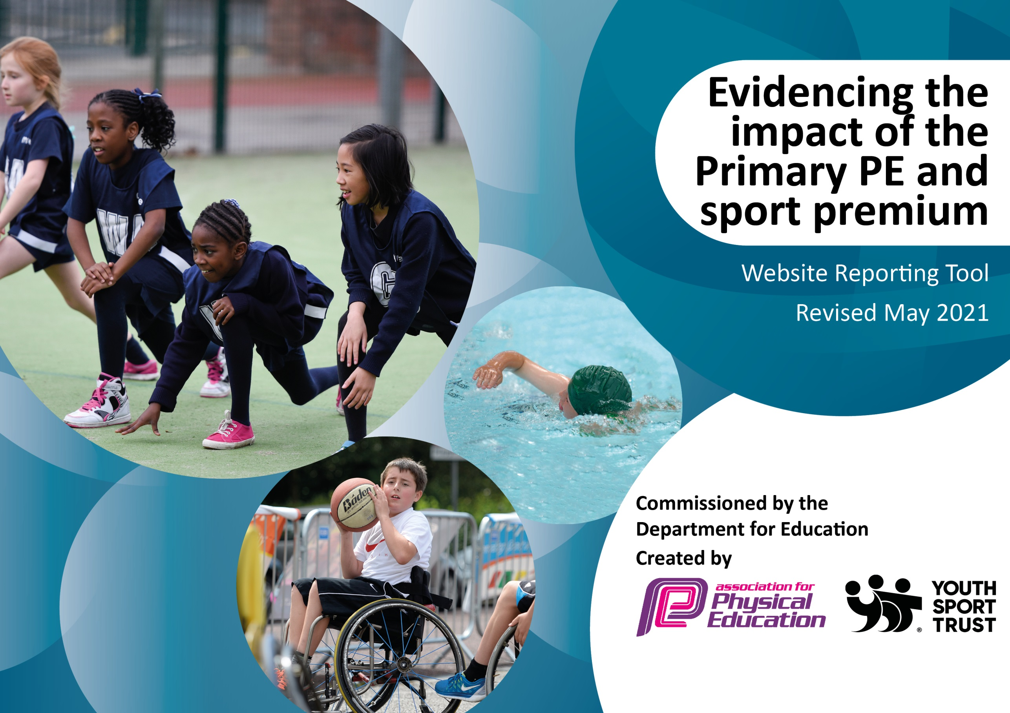

It is important that your grant is used effectively and based on school need. The Education Inspection Framework (Ofsted 2019 p64) makes clear there will be a focus on ‘whether leaders and those responsible for governors all understand their respective roles and perform these in a way that enhances the effectiveness of the school’.

Under the Quality of Education criteria (p41) inspectors consider the extent to which schools can articulate their curriculum (INTENT), construct their curriculum (IMPLEMENTATION) and demonstrate the outcomes which result (IMPACT).

To assist schools with common transferable language this template has been developed to utilise the same three headings which should make your plans easily transferable between working documents.

Schools must use the funding to make additional and sustainable improvements to the quality of Physical Education, School Sport and Physical Activity (PESSPA) they offer. This means that you should use the Primary PE and sport premium to:

- Develop or add to the PESSPA activities that your school already offer
- Build capacity and capability within the school to ensure that improvements made now will benefit pupils joining the school in future years
- The Primary PE and sport premium should not be used to fund capital spend projects; the school’s budget should fund these.
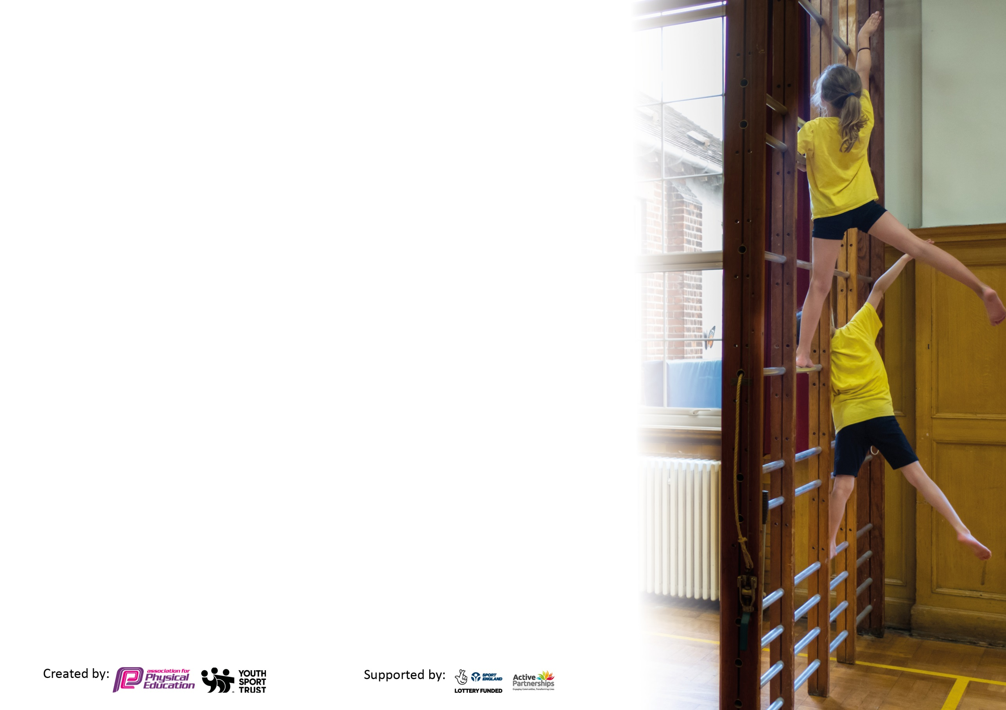
Please visit gov.uk for the revised DfE guidance including the 5 key indicators across which schools should demonstrate an improvement. This document will help you to review your provision and to report your spend. DfE encourages schools to use this template as an effective way of meeting the reporting requirements of the Primary PE and sport premium.

We recommend you start by reflecting on the impact of current provision and reviewing the previous spend.

Schools are required to publish details of how they spend this funding, including any under-spend from 2019/2020, as well as on the impact it has on pupils’ PE and sport participation and attainment by the end of the summer term or by 31st July 2021 at the latest.

We recommend regularly updating the table and publishing it on your website throughout the year. This evidences your ongoing self-evaluation of how you are using the funding to secure maximum, sustainable impact. Final copy must be posted on your website by the end of the academic year and no later than the 31st July 2021. To see an example of how to complete the table please click HERE.

Please note: Although there has been considerable disruption in 2020 it is important that you publish details on your website of how you spend the funding - this is a legal requirement.
Support for review and reflection - considering the 5 key indicators from DfE, what development needs are a priority for your setting and your pupils now and why? Use the space below to reflect on previous spend and key achievements and areas for development.

N.B. In this section you should refer to any adjustments you might have made due to Covid-19 and how these will influence further improvement.
Key achievements to date until July 2021 | Areas for further improvement and baseline evidence of need:
The engagement and increase of pupils in regular physical activity. The new play equipment in the playground, which is coordinated by lunchtime staff, and the excellent Sports Crew that we currently have who run activities every lunchtime, have both added to the focused physical activity.  Forest School has been a huge success at Holy Trinity. It is currently run by a KS1 teacher who spends Friday each week doing a morning and afternoon of Forest School with a year group.  The broader experience of a range of sports and activities offered to all. Over the past few years, the children have experienced, trampolining, golf and badminton. This year we have had a focus on cricket after the enthusiasm amongst the children after the success of the England Cricketers.  Increased participation in competitive sport. We have tried to enter as many MSA events, or other cluster events, as possible over the last two years.  Orienteering course set up on the school grounds.  Focused teacher training on gymnastics and dance which had been two areas that had been identified as areas that teachers felt less confident teaching. | The below was the need that was identified in July 2020. Highlighted in blue are areas that have been achieved. Highlighted in red are areas that had to be adjusted or have not been achieved and will therefore continue to be a focus going forward.  Further development of the PE Curriculum and PE assessment systems. Having introduced a scheme of work to ensure progression, a separate curriculum document is being developed to ensure that all areas are being covered and that there are opportunities for progression for all children. An assessment document (alongside Target Tracker) is also being created to give a better picture of the children that may need extra support of different opportunities to encourage them to be active.  Work on the curriculum, particularly progression and assessment will continue for the academic year 2021/22  Continue to work with our PE specialist teacher to ensure high quality teaching. Ensure that this is sustainable CPD by development of teachers’ confidence, skill set and knowledge.  Discuss with staff and children if there are daily activities that could be introduced that are workable and sustainable - ideas include, the daily mile, yoga in the classroom, a quick hit of exercise such as with Joe Wicks (10-15 mins). We used many of these activities during both lockdowns and the teachers are still continuing to use the activities when it is appropriate.  Continue to raise the profile of sport in the school. Sports Crew board, Sporting Achievement board, information about festivals and competitions in the newsletter. Give more status to events such as Sports Relief.  Ensure that the pupils are being given a voice in the decision making about PE. This was started during school Council meeting at the start of the Spring Term, where the possibility of the children participating in trampolining was suggested.  We carried out pupil surveys after the second lockdown to try to establish who felt they had been active. We also asked what sports/physical activities children enjoyed participating in whilst at school.  New areas to consider and develop:  Fun Sports days/mornings  Daily Mile  Dance and gym focus after these areas not being taught due to the pandemic  Further swimming opportunities in Year 6 (after SATs)

Did you carry forward an underspend from 2019-20 academic year into the current academic year? YES Delete as applicable
Total amount carried forward from 2019/2020 £10,174
+ Total amount for this academic year 2020/2021 £ 19, 450
= Total amount available to be spent by 31st July 2021 £ 29,624

Actual spend 1st September 2020 – 31st July 2021 = £24,719

Carry over = £4,905 to be spent by May 2022
Meeting national curriculum requirements for swimming and water safety.  N.B Complete this section to your best ability. For example you might have practised safe self-rescue techniques on dry land which you can transfer to the pool when school swimming restarts.  Due to exceptional circumstances priority should be given to ensuring that pupils can perform safe self rescue even  if they do not fully meet the first two requirements of the NC programme of study. | 60 Children in Year 6. 59 responses to our survey.
What percentage of your current Year 6 cohort swim competently, confidently and proficiently over a distance of at least 25 metres?  N.B. Even though your pupils may swim in another year please report on their attainment on leaving primary school at the end of the summer term 2021.  Please see note above. | 95%
What percentage of your current Year 6 cohort use a range of strokes effectively [for example, front crawl, backstroke and breaststroke]?  Please see note above. | 87%
What percentage of your current Year 6 cohort perform safe self-rescue in different water-based situations? | 73%
Schools can choose to use the Primary PE and sport premium to provide additional provision for swimming but this must be for activity over and above the national curriculum requirements. Have you used it in this way? | No

Action Plan and Budget Tracking
Capture your intended annual spend against the 5 key indicators. Clarify the success criteria and evidence of impact that you intend to measure to evaluate for pupils today and for the future.

Academic Year: 2020/21 | Total fund allocated: £29,624 | Date Updated: 20.07.21
Key indicator 1: The engagement of all pupils in regular physical activity – Chief Medical Officers guidelines recommend that primary school pupils undertake at least 30 minutes of physical activity a day in school |  |  |  | Percentage of total allocation:
 |  |  |  | 41%
Intent | Implementation |  | Impact
Your school focus should be clear what you want the pupils to know and be able to do and about  what they need to learn and to  consolidate through practice: | Make sure your actions to achieve are linked to your intentions: | Funding allocated: | Evidence of impact: what do pupils now know and what can they now do? What has changed?: | Sustainability and suggested next steps:
To ensure that pupils are remaining physically active at school, under more restricted, limited conditions.  To ensure that pupils are remaining physically active during lockdown, whether they are at home or in school as they are key-worker children.  To continue the school’s commitment to all pupils being able to have active playtimes. The new playground equipment provides a variety of activities for children who perhaps do not wish to engage football or other ball games.  To increase the number of active clubs available to the pupils.  To continue to ensure quality teaching. | JASC coaching to continue to teach two year groups once a week. This provides high quality teaching which is therefore modelled and discussed with the class teacher.  JASC coaching have provided two lessons a week for pupils to access online, including pre-recorded lessons. These have been provided for both KS1 and KS2.  This is alongside the school taking part in Sussex Active Winter Games, Joe Wicks fitness three times a week and encouraging children to use resources such as Cosmic Yoga and Jumpstart Johnny.  Outdoor playground equipment:  Table tennis table, footballs and equipment for individual year groups. Individual year groups needed their own equipment for playtimes due to the children being in bubbles.  We have purchased four new netball posts which will be used for a netball club run by JASC.  PE Hub Planning Scheme | £5,500 (September to July)  See above for cost  Jumpstart Johnny £269  £4144.90 (TT)  £1891.45 (small equipment, including netball posts)  £350 | When the children returned to school in September all pupils were being taught PE outdoors with staff following the Association of Physical Education risk assessment advice.  Discuss with children how they feel about how sport and PE has helped with the return to school. Survey results - The survey results are now helping us to plan for the continued wellbeing of HT pupils through PE and Physical Activity.  We are very aware of the importance of pupils remaining active in lockdown. We provide a set time each day for pupils to engage in at least 30 mins of physical activity. This is the same whether the children are at home or in school.  Many children like to play football or catch at playtimes. This has continued, as has the use of the 4Square pitches. Predominantly the older children (Yr5/6) are currently using the table tennis tables at playtimes.  Staff to be sent the curriculum plan for 2021/22. | A huge focus for the school this academic year is on pupils’ wellbeing during these difficult and challenging times. Remaining physically active is an important part of this. We will be focusing on quality teaching, a variety of sports being taught (by staff or by specialists when possible) and the provision of equipment to enable active playtimes.  The younger children being given the opportunity to practise using the table tennis tables to increase their confidence to use them.  PE Co-ordinators to continue discussing the effectiveness of these plans and to continue to monitor the progression within the PE Curriculum.
Key indicator 2: The profile of PESSPA being raised across the school as a tool for whole school improvement |  |  |  | Percentage of total allocation:
 |  |  |  | 12%
Intent | Implementation |  | Impact
Your school focus should be clear what you want the pupils to know and be able to do and about  what they need to learn and to  consolidate through practice: | Make sure your actions to achieve are linked to your intentions: | Funding allocated: | Evidence of impact: what do pupils now know and what can they now do? What has changed?: | Sustainability and suggested next steps:
To ensure that children’s wellbeing is supported through PESSPA on the return to school after the first and second lockdowns.  Through Forest School – helping the children to see the variety of Physical Activity that they can be involved in.  To raise the profile of School Sports- and competitive sports despite there being no events this year.  To provide time for the OPE Co-ordinators to assess funding, teaching and learning and progress of the action plan. | Lockdown and return to school action plan: please see attached document.  Holy Trinity took part in the Winter Games to engage children during the January 2021 Lockdown in a variety of different physical activities.  Children in each Year Group have a morning or afternoon at Forest School.  Sussex Cricket came in to work with both Year 6 and Year 4. His provided an opportunity for the children to engage in more competitive sports.  Subject Leaders time – 2 hours per week | No funding required  No funding required for Forest School this academic year from the Sports Premium.  No funding required  £3,563.70 | The main benefit of the Winter Games was to help children keep active inside during the winter months of the second Lockdown.  We have seen the benefits of Forest School across the school. Children who perhaps find the traditional learning environment of the classroom difficult have flourished with the opportunity to learn outside. | All staff are being encouraged to create active outdoor lessons (Physical Activity). Outdoor lesson provision is being monitored by the Forest School Co-ordinator.

Key indicator 3: Increased confidence, knowledge and skills of all staff in teaching PE and sport |  |  |  | Percentage of total allocation:
 |  |  |  | 10%
Intent | Implementation |  | Impact
Your school focus should be clear | Make sure your actions to | Funding | Evidence of impact: what do | Sustainability and suggested
what you want the pupils to know | achieve are linked to your | allocated: | pupils now know and what | next steps:
and be able to do and about | intentions: |  | can they now do? What has
what they need to learn and to |  |  | changed?:
consolidate through practice:
To ensure that teachers are confident teaching and assessing a range of Sports and Physical Activities. Our intent is to give teachers opportunities to see PE and Sports Specialist providing both ideas and techniques for teaching.  To ensure that staff are assessing the children accurately for PE and Sport. This will help the PE Co-ordinators to understand if there are any children that need further support.  Further staff training:  To assist the PE Co-ordinator with understanding the best way structure the PE curriculum during lockdowns and post lockdown in school. | JASC - Provide teaching to two Year Groups. During the Summer Term They have also organised Year Group Sports mornings/afternoons.  JOLF – golf lessons for KS1 and an opportunity for staff to see a different strategy for teaching PE lessons.  New assessment tool introduced at the start of the Summer Term  Return to School Seminar run by Mid-Sussex Active | See above for costs  £3000  N/A  N/A | The teachers have continued to be more confident about teaching a range of PE and SS. This has meant that children have had good quality teaching during two lessons each week.  PE co-ordinators to assess use so far. | JASC to learn and help teachers to teach orienteering in the grounds from next academic year.  To implement the tool further next academic year.
Key indicator 4: Broader experience of a range of sports and activities offered to all pupils |  |  |  | Percentage of total allocation:
 |  |  |  | 10% (but a repeated cost)
Intent | Implementation |  | Impact
Your school focus should be clear | Make sure your actions to | Funding | Evidence of impact: what do | Sustainability and suggested
what you want the pupils to know | achieve are linked to your | allocated: | pupils now know and what | next steps:
and be able to do and about | intentions: |  | can they now do? What has
what they need to learn and to |  |  | changed?:
consolidate through practice:
Additional achievements:  We have tried to ensure that children have access to a range of sports despite the Lockdown in January and the continued restrictions on Sporting Events. | JOLF (see above)  Sussex Cricket (see above)  Winter Games (see above) | See above for JOLF costs | The results of the survey are now helping to inform our planning for Sports Specialists and curriculum focus. | The children have asked to have trampolining again as a school activity. This is currently being researched.

Key indicator 5: Increased participation in competitive sport |  |  |  | Percentage of total allocation:
 |  |  |  | 20%
Intent | Implementation |  | Impact
Your school focus should be clear | Make sure your actions to | Funding | Evidence of impact: what do | Sustainability and suggested
what you want the pupils to know | achieve are linked to your | allocated: | pupils now know and what | next steps:
and be able to do and about | intentions: |  | can they now do? What has
what they need to learn and to |  |  | changed?:
consolidate through practice:
This has been an area of difficulty this academic year with no external sporting events taking place at all. We have continued to encourage competitive sport during the units of teaching. Every year group has had a sports morning or afternoon, with KS2 having a competitive element to their Sports Day.  To continue to increase pupil participation in, and enjoyment of, competitive activities.  To continue to develop a variety of children’s ability to  lead and organise sporting activities  Support for subject leader and in turn the subject leader is able to confidently support and guide teaching staff. | MSA Partnership - continued membership with Mid Sussex Active.  Mid Sussex Active provide:  extensive quality assured professional development programme for teaching staff  access to a wide range of inter- school competitions and festivals for children from R – Yr6  training to develop young people as sports leaders  specialist advice and support from our local secondary schools  support, training and  networking opportunities for PE  co-ordinator and other members of staff.  see www.midsussexactive.org.uk for further information and reports about events/training/calendar etc  TAs and teachers to be released during school hours to attend events. | £6000 (for two years)

Signed off by
Head Teacher: | Ann MacGregor
Date: | 23rd July 2021
Subject Leader: | Zoe Macwhinnie
Date: | 22/07/21
Governor: | Fiona Halsey
Date: | 23rd July 2021

