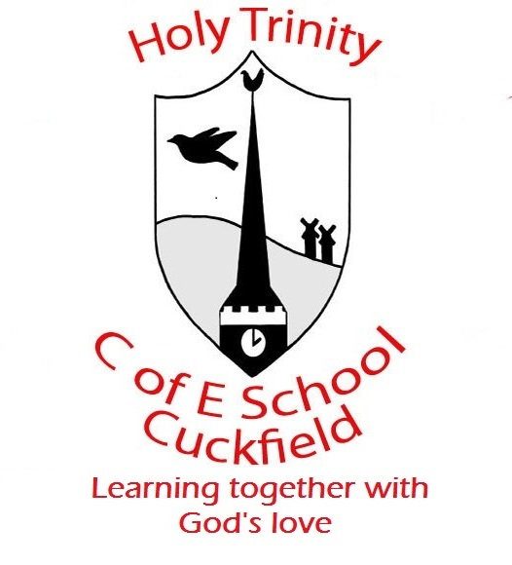 Update from Reception Week 4 (Spring)

Week Beginning- Spring 2020, week 4, 27.1.20
Dear Parents,
Last week the children enjoyed finding out about South Korea and Chinese New Year. They also enjoyed trying food from Asia.
This week Sailor Bear is continuing his journey from South Korea to Australia. In our language work we will be using information and story books to find out more about Australia. We will be looking at aboriginal art and listening to aboriginal music. We will be thinking about hot and cold countries and which animals live there. We will be focusing on reading the tricky words- ‘he’, ‘she’ and ‘me’.
In Mathematics we are focusing on ways of making 9 and 10. We will also be using the language more, fewer and the same as to compare groups of objects. Our number for the week is ‘16’ and our shape for the week is a star.
If you have any experience or knowledge about Australia that you would like to share with the class we’d love to hear from you.
Many Thanks for your help and support
The Early Years Team

