Shape activity
At home, or when you are out, look at the surface of shapes.
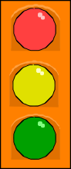
- Ask your child – what shape is this plate, this mirror, the bath mat, the tea towel, the window, the door, the red traffic light, and so on.
- Choose a shape for the week, e.g. a square. How many of these shapes can your child spot during the week, at home and when you are out?

Dice game
You need a 1–6 dice, paper and pencil.
- Take turns.
- Choose a number between 1 and 10 and write it down.
- Throw the dice and say the dice number.
- Work out the difference between the chosen number and the dice number, e.g. if you wrote down a 2 and the dice shows 5, the difference is 3.
You could also draw a number line to help your child to see the difference between the two numbers.
Supporting your child at home

3
0 1 2 3 4 5 6 7 8 9 10
1

A booklet for parents

Takings

For this game you will need a dice and a collection of small things such as Lego bricks, sticky shapes or dried pasta. You will also need pencil and paper.
• Take turns.
• Roll a dice. Take that number of pieces of pasta. Write down the number.
• Keep rolling the dice and taking that number of pieces of pasta. BUT, before you take them, you must write down your new total.
For example, Sally has 7. She throws 4. She has to work out how many she will have now. She starts counting from seven: eight, nine, ten, eleven. She writes 11.
• You can only take your pieces of pasta if you are right.
• The first person to collect 20 beans wins!
Dicey coins
For this game you need a dice and about twenty 10p coins.
- Take turns to roll the dice and take that number of 10p coins.
- Guess how much money this is. Then count aloud in tens to check, e.g. saying ten, twenty, thirty, forty…
- If you do this correctly you keep one of the 10p pieces.
- First person to collect £1 wins.
- Don't forget to give the coins back!

Secret numbers

  - Write the numbers 0 to 20 on a sheet of paper.
  - Ask your child secretly to choose a number on the paper. Then ask him / her some questions to find out what the secret number is, e.g.
Is it less than 10?
Is it between 10 and 20? Does it have a 5 in it?
He / she may answer only yes or no.
  - Once you have guessed the number, it is your turn to choose a number. Your child asks the questions.
For an easier game, use numbers up to 10. For a harder game, use only 5 questions, or use bigger numbers.

.

Track games
About the statements
These statements show some of the things your child should be able to do by the end of Year 1.

Some statements are harder than they seem, e.g. children who can count up to 20 may still have trouble saying which number comes after 12. They may have to start at 1 and count from there.
Make a number track to 20, or longer. Make it relevant to your child’s interests – sea world, space, monsters… Then play games on it.

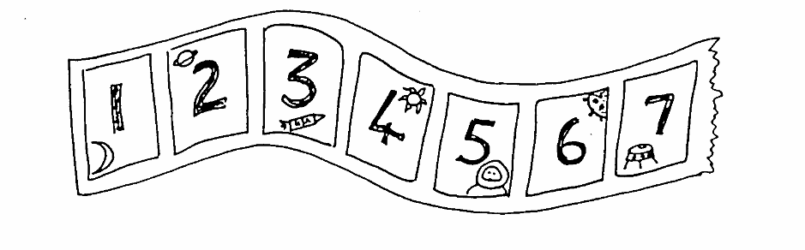
- Throw a dice. Move along that number of spaces. BUT before you move, you must work out what number you will land on. If you are wrong, you don’t move! The winner is the first to land exactly on 20. Now play going backwards to 1.
- Throw a dice. Find a number on the track that goes with the number thrown to make either 10 or 20. Put a counter on it, e.g. you throw a ‘4’ and put a counter on either 6 or 16. If someone else’s counter is there already, you may replace it with yours! The winner is the first person to have a counter on 8 different numbers.

Cupboard maths
- Choose two tins or packets from your food cupboard.
- Ask your child to hold one in each hand and tell you which is heavier, and which is lighter. (Check by reading the weight on each tin or packet.)
- If he / she is right, they keep the lighter one. Then choose another item from the cupboard, trying to find one that is lighter still.
- Carry on until your child has found the lightest item in the cupboard. It might be suitable to eat as a prize!

Fun activities to do at home

Adding circles
For this game, you need a dice and pencil and paper.
- Each of you should draw four circles on your piece of paper. Write a different number between 2 and 12 in each circle.

2
6
8
9

- Roll the dice twice. Add the two numbers.
- If the total is one of the numbers in your circles then you may cross it out.
- The first person to cross out all four circles wins.

Out and about
On the way to school, see how many cuboids, spheres and cylinders you can spot. Which did you see most of?

Housey, housey

When walking down the street with your child, look at house numbers.
These will probably be following a pattern of either odd or even numbers.
Can your child predict what number will be on the next house? Talk about the pattern.
.

How old?
Start with your child’s age. Ask your child:
How old will you be when you are 1 year older? How old were you last year?
How old will you be 10 years from now? and so on.

You can find further information regarding the school’s calculation policy and details of the methods taught to each year group on the school’s website or by following this link:
http://holy-trinity-cuckfield.eschools.co.uk/website/supporting_your_child_in_maths/18632

