E4S KS1 Eating well and being active – Being healthy and active

Cornerstone: | PHWB
Concept: | Eating well and being active
Theme: | Being healthy and active
Key Questions: | Teachers have used the questions and statements from the E4S curriculum to plan lessons on being safe, which are delivered throughout the year according to the school’s scheme of work.  This is what your child will be learning about in the upcoming scheme of work:  - What does it mean to be healthy and active and what can we do to keep this way?  - What things can we do when we feel healthier?  - What do healthy people do some of the time? All of the time? Never?  - How can we keep active to keep healthy?  - What might happen if we are not physically active?  - What does food do to our health?  - What does a ‘healthy diet’ mean?  - How does what we eat affect our bodies and minds?  - What do we know about healthy eating and how it can help keep our bodies healthy?
Questions to consider with your child: | What does it mean to be healthy and active?  Why is this important?  What things do you enjoy doing to keep yourself active?  What are your favourite healthy foods?  What can you do to relax and calm your mind?
Suggested Resources for parents: | Please find additional support and guidance below in relation to being healthy and active.  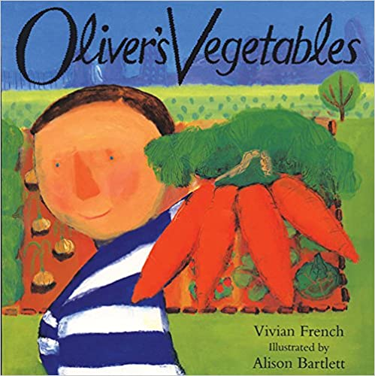  Healthy Eating Advice  Healthy Eating Online Games  NHS - Healthier Families  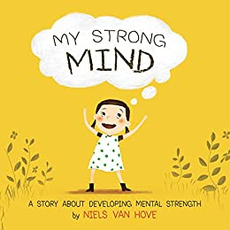  Oliver's Vegetables My Strong Mind

