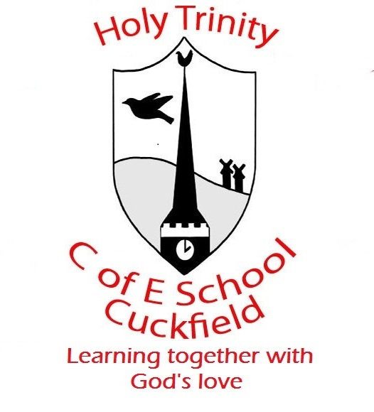 Update from Reception Week 3 (Spring)

Week Beginning- Spring 2020, week 3, 20.1.20
Dear Parents,
Last week the children enjoyed reading our book Penguin Post and taking on roles in our post office. They enjoyed working as post office assistance, being customers and delivering their letters to people. The children wrote a letter to a friend/family member and we are looking forward to receiving some letters.
This week Sailor Bear is hitching a ride on a whale and he will be visiting South Korea. This week our book is a non-fiction text that follows a little boy who lives in South Korea. We will be looking at maps to see where we live and where Sailor Bear has travelled so far. Min enjoys going skiing with his family and we will be asking the children what they enjoy doing with their family.
In Mathematics we are thinking about direction and positioning. If you can talk to you children about directions (left, right, North, East, South and West). We will be exploring positioning by placing teddies in different places; for example – the teddy is under the table, next to the chair, in between the tree and the house.

Many Thanks for your help and support
The Early Years Team

