Reading

- Identify which words appear again and again.
- Recognise and join in with predictable phrases.
- Relate reading to own experiences.
- Re-read if reading does not make sense.
- Re-tell with considerable accuracy.
- Discuss significance of title and events.
- Make predictions on basis of what has been read.
- Make inferences on basis of what is being said and done.
- Read aloud with pace and expression, i.e. pause at full stop; raise voice for question.
- Recognise:
  - capital letters
  - full stops
  - question marks
  - exclamation marks
  - ellipsis
- Know why the writer has used the above punctuation in a text.
- Know difference between fiction and non- fiction texts.

Writing

- Write clearly demarcated sentences.
- Use ‘and’ to join ideas.
- Use conjunctions to join sentences (e.g. so, but).
- Use standard forms of verbs, e.g. go/went.
- Introduce use of:
  - capital letters
  - full stops
  - question marks
  - exclamation marks
- Use capital letters for names and personal pronoun ‘I’.
- Write a sequence of sentences to form a short narrative [as introduction to paragraphs].
- Use correct formation of lower case – finishing in right place.
- Use correct formation of capital letters.
- Use correct formation of digits.

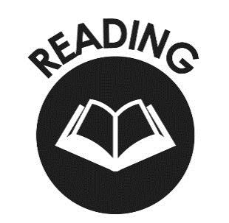

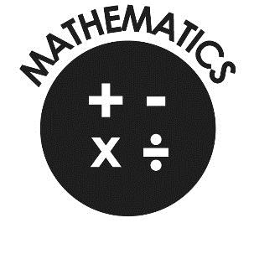
Mathematics
- Count to and across 100, forwards & backwards from any number.
- Read and write numbers to 20 in numerals & words.
- Read and write numbers to 100 in numerals.
- Say 1 more/1 less to 100.
- Count in multiples of 2, 5 & 10.
- Use bonds and subtraction facts to 20.
- Add & subtract 1 digit & 2 digit numbers to 20, including zero.
- Solve one-step multiplication and division using objects, pictorial representation and arrays.
- Recognise half and quarter of object, shape or quantity.
- Sequence events in chronological order.
- Use language of day, week, month and year.
- Tell time to hour & half past.

End of Year Expectations for Year 1

This booklet provides information for parents and carers on the end of year expectations for children in our school. The National Curriculum outlines these expectations as being the minimum requirements your child must meet in order to ensure continued progress.

All the objectives will be worked on throughout the year and will be the focus of direct teaching. Any extra support you can provide in helping your children to achieve these is greatly valued.

If you have any queries regarding the content of this booklet or want support in knowing how best to help your child please talk to your child’s teacher.

