8th March 2026

Dear Parent / Guardian

We are very excited to announce that we have confirmed 2 dates for our popular multi-sports Activity days for the upcoming Easter holiday period.

The dates are:

Monday 30th March
Tuesday 31st March

The activity days will be based at Downlands Community School Sports Centre, Dale Avenue, Hassocks, BN6 8LP.

All our staff are qualified PE teachers with experience of both secondary and junior school provision. As the camp providers we are an experienced company who currently operate several after-school clubs and a recreational gymnastics club in the area as well as teaching in many of the local primary, junior and infant schools.

When attending the camp students will take part in an organised programme of events. This will include activities such as teambuilding, problem solving, football, basketball, dance, gymnastics, rounders, cricket, dodgeball, badminton, athletics and many more. The programme aims to help the students interact with each other, develop new skills and relationships all whilst having fun.

The days will run from 9am-3pm and are aimed for children in Years 1 – 6. The cost for the camp is £35.00 per child per day.

If you would like to book your child a space, please email jennyjasc@gmail.com as soon as possible as places will be allocated on a first come first served basis.

We look forward to hearing from you.

Yours sincerely,

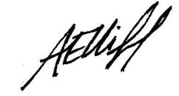
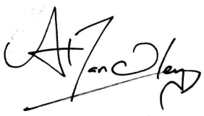

Jenny Handley Abi Elliff

