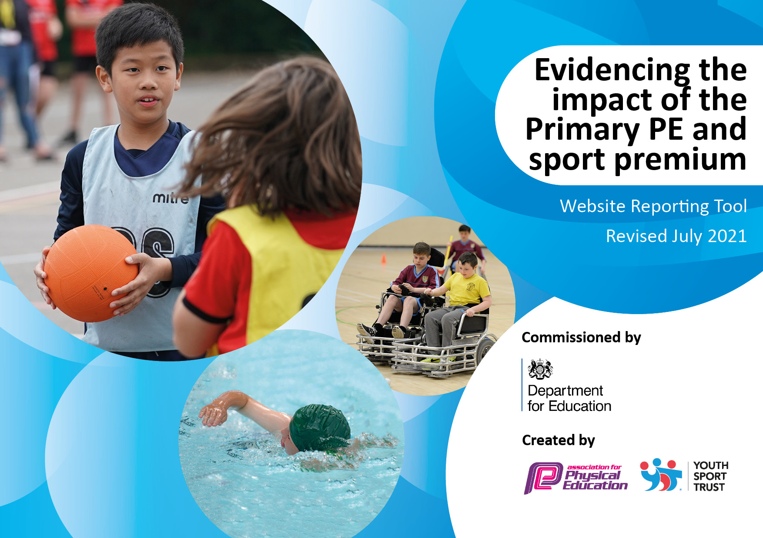
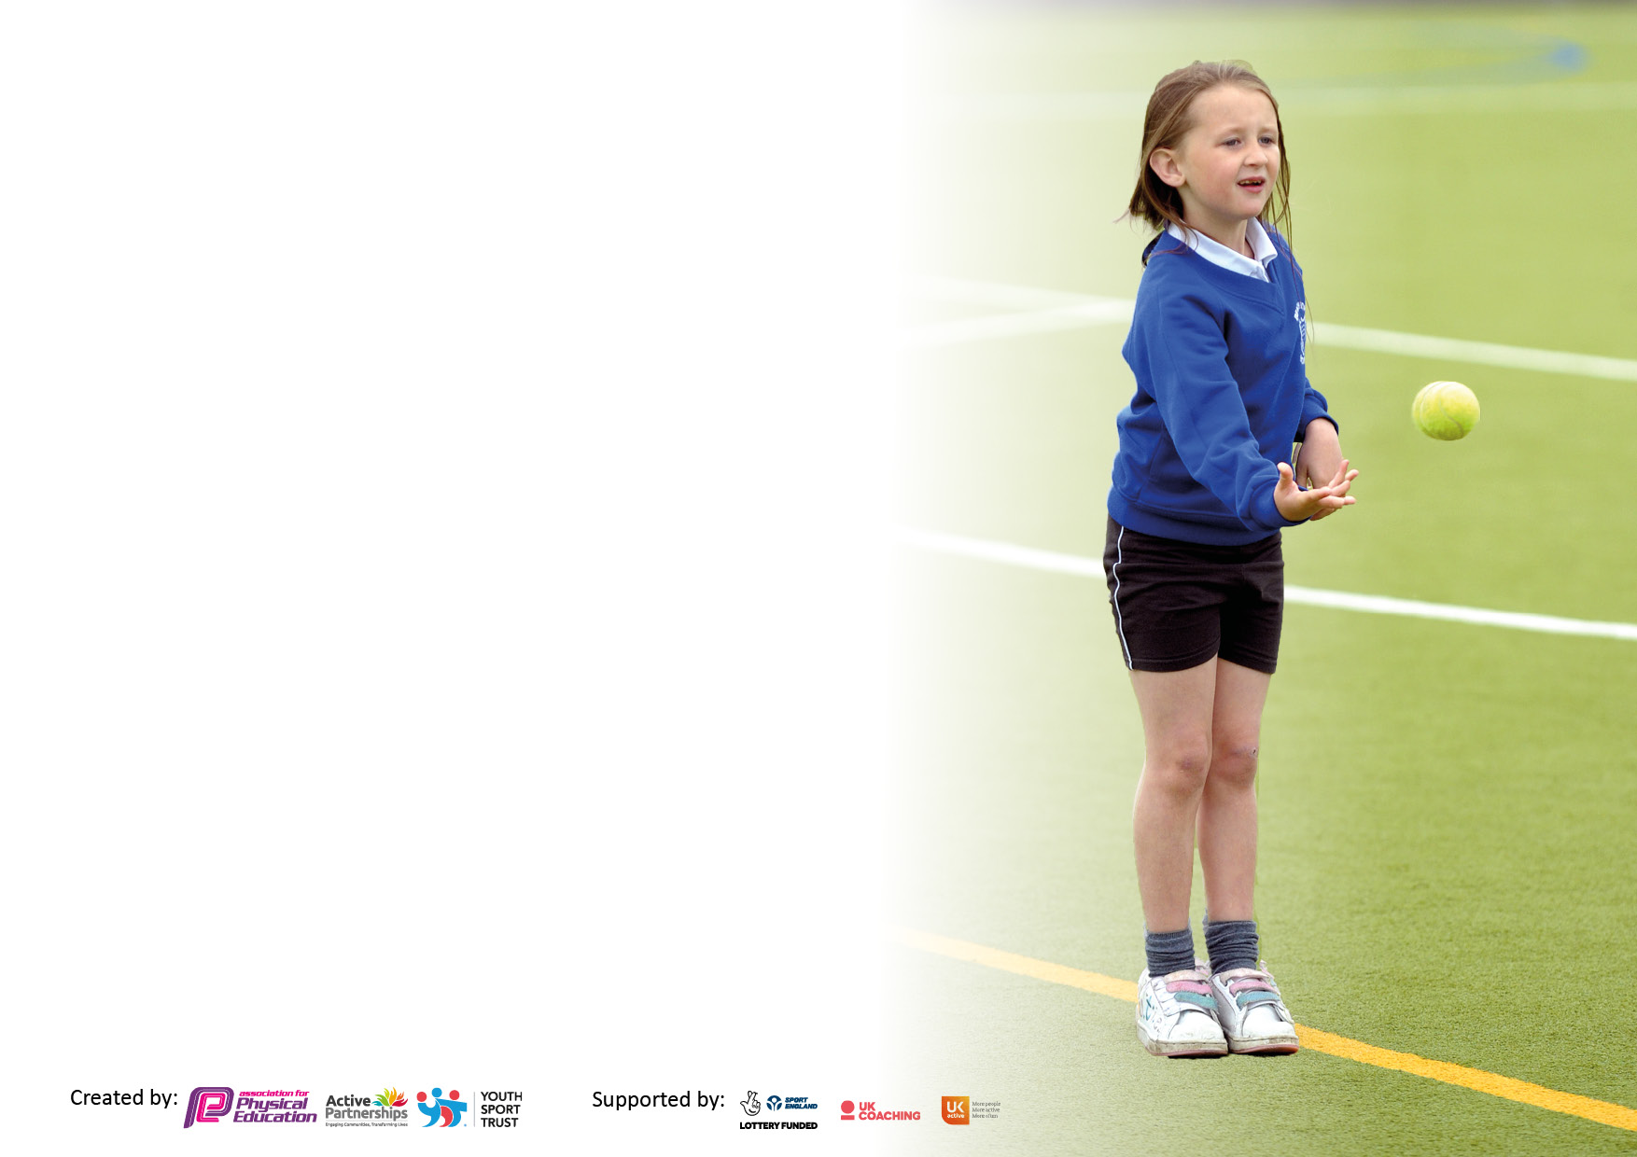

It is important that your grant is used effectively and based on school need. The Education Inspection Framework makes clear there will be a focus on ‘whether leaders and those responsible for governors all understand their respective roles and perform these in a way that enhances the effectiveness of the school’.

Under the Quality of Education Ofsted inspectors consider:
Intent - Curriculum design, coverage and appropriateness
Implementation - Curriculum delivery, Teaching (pedagogy) and Assessment
Impact - Attainment and progress

To assist schools with common transferable language this template has been developed to utilise the same three headings which should make your plans easily transferable between working documents.

Schools must use the funding to make additional and sustainable improvements to the quality of Physical Education, School Sport and Physical Activity (PESSPA) they offer. This means that you should use the Primary PE and sport premium to:

- Develop or add to the PESSPA activities that your school already offer
- Build capacity and capability within the school to ensure that improvements made now will benefit pupils joining the school in future years
- The Primary PE and sport premium should not be used to fund capital spend projects; the school’s budget should fund these.

Please visit gov.uk for the revised DfE guidance including the 5 key indicators across which schools should demonstrate an improvement. This document will help you to review your provision and to report your spend. DfE encourages schools to use this template as an effective way of meeting the reporting requirements of the Primary PE and sport premium.

We recommend you start by reflecting on the impact of current provision and reviewing the previous spend.

Schools are required to publish details of how they spend this funding, including any under-spend from 2019/2020, as well as on the impact it has on pupils’ PE and sport participation and attainment. All funding must be spent by 31st July 2022.

We recommend regularly updating the table and publishing it on your website throughout the year. This evidences your ongoing self-evaluation of how you are using the funding to secure maximum, sustainable impact. Final copy must be posted on your website by the end of the academic year and no later than the 31st July 2021. To see an example of how to complete the table please click HERE.

Details with regard to funding
Please complete the table below.

Total amount carried over from 2019/20 | £10,174
Total amount allocated for 2020/21 | £19, 450
How much (if any) do you intend to carry over from this total fund into 2021/22? | £4,905
Total amount allocated for 2021/22 | £19,590.00
Total amount of funding for 2021/22. To be spent and reported on by 31st July 2022. | £24,495
Swimming Data
Please report on your Swimming Data below.

Meeting national curriculum requirements for swimming and water safety.

N.B. Complete this section to your best ability. For example, you might have practised safe self-rescue techniques on dry land which you can then transfer to the pool when school swimming restarts.
Due to exceptional circumstances priority should be given to ensuring that pupils can perform safe self rescue even if they do not fully meet the first two requirements of the NC programme of study
What percentage of your current Year 6 cohort swim competently, confidently and proficiently over a distance of at least 25 metres?  N.B. Even though your pupils may swim in another year please report on their attainment on leaving primary school at the end of the summer term 2020.  Please see note above | 77%
What percentage of your current Year 6 cohort use a range of strokes effectively [for example, front crawl, backstroke and breaststroke]?  Please see note above | 84%
What percentage of your current Year 6 cohort perform safe self-rescue in different water-based situations? | 77%
Schools can choose to use the Primary PE and sport premium to provide additional provision for swimming, but this must be for activity over and above the national curriculum requirements. Have you used it in this way? | No

Action Plan and Budget Tracking
Capture your intended annual spend against the 5 key indicators. Clarify the success criteria and evidence of impact that you intend to measure to evaluate for pupils today and for the future.

Academic Year: 2020/21 | Total fund allocated: | Date Updated:
Key indicator 1: The engagement of all pupils in regular physical activity – Chief Medical Officers guidelines recommend that primary school pupils undertake at least 30 minutes of physical activity a day in school |  |  |  | Percentage of total allocation:
 |  |  |  | 9.7%
Intent | Implementation |  | Impact
Your school focus should be clear what you want the pupils to know and be able to do and about  what they need to learn and to  consolidate through practice: | Make sure your actions to achieve are linked to your intentions: | Funding allocated:  £2386.20 | Evidence of impact: what do pupils now know and what can they now do? What has changed?: | Sustainability and suggested next steps:
To continue the school’s commitment to all pupils being able to have active playtimes. The new playground equipment provides a variety of activities for children who perhaps do not wish to engage in football or other ball games.  To increase the number of active clubs available to the pupils. Clubs were stopped during the pandemic. The school now wants to run a full timetable of clubs.  To continue to ensure quality teaching. To have clear plans across the school which show a clear progression of skills.  To provide a classroom based physical activity that can be used as a short mental break or when the outside space cannot be used due to bad weather – ice or heavy rain. | The school council have chosen equipment that they would like to have for playtimes. They will set up a rota for classes to use the equipment at different times during the week.  A range of clubs have been organised by the school meaning that children have opportunities to experience a range of sports. See attached timetable for the summer term.  The school has continued to use PE Hub plans this academic year. These plans have continued to ensure that teachers are teaching units of a variety of sports and physical activities.  Implementation of Jump Start Jonny which can be used in all classrooms. | Playground equipment (school council) - £700.75  Other equipment - £1056.45  The clubs are paid for by parents apart from for Pupil Premium children.  £350  £279 | The school council chose the equipment themselves. This equipment helps the children to have choice at playtimes, providing a variety of ways for them to be active.  The children’s parents are informed of all the various clubs.  Two PE lessons a week are being consistently taught by all classes. Staff are confident at using the plans and are able to adapt the plans to suit the needs of their class. | School council, plus certain adults, are responsible for ensuring that this equipment is used for active playtimes.  Consider other activities/option for the whole school to be active, e.g some form of daily mile or skip.  Currently we are happy with the quality of the teaching plans, plus the use of JASC plans for certain lessons. This is an area we will continue to review.
Key indicator 2: The profile of PESSPA being raised across the school as a tool for whole school improvement |  |  |  | Percentage of total allocation:
 |  |  |  | 2.7%
Intent | Implementation |  | Impact
Your school focus should be clear what you want the pupils to know and be able to do and about  what they need to learn and to  consolidate through practice: | Make sure your actions to achieve are linked to your intentions: | Funding allocated:  £672 | Evidence of impact: what do pupils now know and what can they now do? What has changed?: | Sustainability and suggested next steps:
To raise the profile of School Sports- and competitive sports.  For the Sports Crew to run activities three lunchtimes a week which they have planned, organised and then carry out. This is an opportunity for Year 6 to have pupil voice and develop their leadership skills. To provide an additional structured exercise opportunity for children across KS1 and KS2.  To raise the profile of sport, physical activity and the Sports Crew.  To help the profile of Holy Trinity Sport and PE to be raised internally and externally. | Children are presented with certificates during achievement worship and their participation and successes are recorded in the School newsletter.  Subject leader and Year 6 pupils attended the Sports Crew Training.  The specialist PE teacher (from JASC) met with the Sports Crew to help them to structure their activities.  To create a Sport/PE board and Sports Crew Board Board – a celebration of all the sports that are taking place in the school, lessons, competitions, special visitor sessions, sports specialist sessions and Sports Crew sessions  Kits for children  Kit for adult – options currently being | £ N/A  £672  £432– remaining in budget for this | Children are more aware of all the competitions and festivals that the school is taking part in. We are continuing to ensure that as many children as possible have the opportunity to take part in these events.  This again has been a successful way to encourage a range of children to be active at playtimes.  Sports Crew also provides excellent leadership opportunities, including helping with the younger children during the JOLF (golf) play days.  The younger year groups are more aware of Sports Crew and what they provide.  Children will feel more of team and have more pride in representing the school with new matching kits. | We will continue to be members of Mid-Sussex Active.  Consider starting this in earlier in the academic year by conducting our own training.

Key indicator 3: Increased confidence, knowledge and skills of all staff in teaching PE and sport |  |  |  | Percentage of total allocation:
 |  |  |  | 46%
Intent | Implementation |  | Impact
Your school focus should be clear | Make sure your actions to | Funding | Evidence of impact: what do | Sustainability and suggested
what you want the pupils to know | achieve are linked to your | allocated:  £11,264.7 | pupils now know and what | next steps:
and be able to do and about | intentions: |  | can they now do? What has
what they need to learn and to |  |  | changed?
consolidate through practice:
To ensure that teachers are confident teaching and assessing a range of Sports and Physical Activities. Our intent is to give teachers opportunities to see PE and Sports Specialist providing both ideas and techniques for teaching.  To implement a more organised sports day for both KS1 and KS2. To ensure that there is a clear competitive element in the KS2 event.  To ensure that staff are assessing the children accurately for PE and Sport. This will help the PE Co-ordinators to understand if there are any children that need further support.  To train staff on a new sport to broaden the curriculum that is being taught.  To attend courses looking at the best use of the Sport Premium money and courses such as inclusion for all children.  Courses attended:  PE conference  Online training on use of Sports Premium budget  First steps dance and gym  First step athletics and striking and fielding  To ensure implementation and sustainability of Sport Premium Funding, organisation of events/administration in relation to the School Games Mark, development of curriculum and assessment documents.  To continue to encourage the teaching of gymnastics. | The school is employing a specialist PE teacher from JASC Sports.  The specialist teacher is modelling excellent teaching in areas that have been identified an area in need of training across the staff. This year a key area of focus was orienteering. The sports specialist used the outdoor area, field and woods. She was able to show staff how to use the resources that the school already had in place.  The specialist teacher has helped train and run the Sports Crew enabling them to develop their leadership skills and to provide an opportunity for them to have pupil voice.  The specialist teacher has helped monitor the curriculum coverage and has made suggestions about how to track the progression and attainment of the children.  The specialist teacher helped the PE Lead to organise and implement Sports Day for KS1 and KS2.  The sports specialist runs a netball club.  Staff meeting held in summer term 2021 to implement the new assessment document. By December 2021 staff should have filled in the document for two units. PE Leaders have identified a few issues that need to be discussed with staff at a further staff meeting.  Staff meeting on June 23rd 2022 with a representative from Badminton England to train staff across the school how to introduce and teach badminton. We are looking to implement badminton into the curriculum, via the Racket Pack cards initially, in years 1, 3 and 5.  Subject Leader time  Teachers had highlighted that the heaviness of the current gym mats makes it difficult to conduct a lesson on their own as the mats are too heavy children to move. New lightweight mats have been purchased. | £5950  (July - £350)  £90.99 netball post weights  £45  £180  N/A  £913  £3560.76  £524.95 | The confidence of teachers has grown hugely having had the specialist teacher demonstrating and team teaching with them. The enthusiasm for PE is higher and the two lessons of PE (indoor and outdoor) are being consistently taught across the school. The children are being taught to a higher standard, with clear learning challenge and success criteria and well-structured lessons.  The number of children that are now engaged in a physical activity during playtimes has increased. The year 6 sports crew members are running the sessions independently.  This year our sports specialist has worked with children in Reception and Year 1 who have been identified as struggling either with motor skills or concentration skills. She has worked with small intervention groups with the children from year 1.  Teachers were able to use this training in their lessons.  Continuing to ensure that the Sport Premium money is being spent effectively and sustainably. Provision of opportunities for all children to attend events. Creation of a curriculum that shows progression and identifies areas that need development for both children and teachers. | We will continue to work with JASC next year. The focus will again be on orienteering. We will be asking the specialist coach to help the PE Leads to ensure that the curriculum is being taught to a good standard and that progression is taking place across the year groups.  We are looking at ways to amend the assessment document to highlight children who are exceeding expectations. We can then help them to find local pathways into sports, if that is something that they would like to pursue.  We will continue to attend courses and use staff meeting time for training. This is to provide new ideas and to help teachers to feel increasingly confident about teaching a range of PE and sport.
Key indicator 4: Broader experience of a range of sports and activities offered to all pupils |  |  |  | Percentage of total allocation:
 |  |  |  | 10.3%
Intent | Implementation |  | Impact
Your school focus should be clear | Make sure your actions to | Funding | Evidence of impact: what do | Sustainability and suggested
what you want the pupils to know | achieve are linked to your | allocated:  £2520 | pupils now know and what | next steps:
and be able to do and about | intentions: |  | can they now do? What has
what they need to learn and to |  |  | changed?
consolidate through practice:
To encourage children to take part in a variety of sports to increase the enjoyment and participation of physical activities.  JOLF has been identified as a provider that works very well in KS1 as it helps to develop basic coordination and teamwork skills.  To provide an outdoor opportunity which promotes being active and helps with the children’s wellbeing.  To implement badminton into the taught curriculum | JOLF Playdays  KS1 and Reception will work with JOLF each week for 6 weeks. (Playdays again in the Summer Term)  Each year group goes to Forest School one morning or afternoon per term  Please see above for action taken. | £1200  Deposit cost  £1320 | The playdays worked brilliantly this year, with different year groups working with each other. The older children helped the younger children and the older children had the opportunity to play competitively.  This continues to be a huge success, particularly for children who perhaps find the norms of learning in the classroom a challenge. | We will be working with JOLF next year, particularly in KS1.  Another member of staff has been trained in Forest School.

Key indicator 5: Increased participation in competitive sport |  |  |  | Percentage of total allocation:
 |  |  |  | 29.5%
Intent | Implementation |  | Impact
Your school focus should be clear | Make sure your actions to | Funding | Evidence of impact: what do | Sustainability and suggested
what you want the pupils to know | achieve are linked to your | allocated:  £7230 | pupils now know and what | next steps:
and be able to do and about | intentions: |  | can they now do? What has
what they need to learn and to |  |  | changed?:
consolidate through practice:
To continue to increase pupil participation in, and enjoyment of, competitive activities.  To continue to develop a variety of children’s ability to  lead and organise sporting activities  Support for subject leader and in turn the subject leader is able to  confidently support and guide teaching staff.  For as many children across year groups and abilities to attend festivals and tournaments. | MSA Partnership - continued membership with Mid Sussex Active.  Mid Sussex Active provide:  extensive quality assured professional development programme for teaching staff  access to a wide range of inter- school competitions and festivals for children from R – Yr6  training to develop young people as sports leaders  specialist advice and support from our local secondary schools  support, training and  networking opportunities for PE  co-ordinator and other members of staff.  see www.midsussexactive.org.uk for further information and reports about events/training/calendar etc | £7000 (until 2025)  Coach costs  £230 | This will be evidenced through the data gathered of how many children attended MSA or cluster events.  Over the time that events were running (September 2021-July 2022) the following percentages of children took part in events:  Year 3 – 53%  Year 4 – 48%  Year 5 – 34%  Year 6 – 65%  19 children in Year 6 were involved in Sports Crew and the leadership opportunities that this provides.  See above for the evidence in relation to the impact of the Sports Crew and the involvement of School Council.  Support received from Active Sussex in terms of Sports Premium documentation. | We will be aiming for a greater percentage of children to attend a variety of events, especially the year 5 children moving into year 6.

Signed off by
Head Teacher: | Ann MacGregor
Date: | 20th July 2022
Subject Leader: | Zoe Macwhinnie
Date: | 19th July 2022
Governor: | Fiona Halsey
Date: | 20th July 2022

