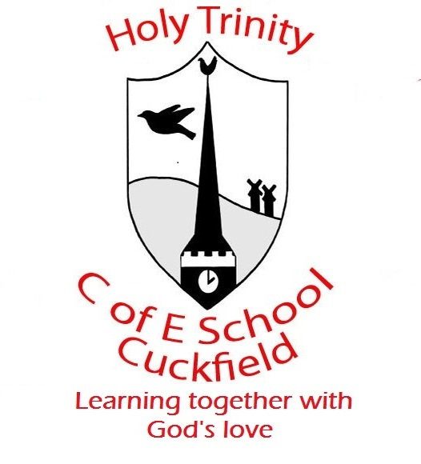 Update from Year 1 for Week 3

Dear Parents / Carers, Date: 16.01.20
We are still collecting boxes and tubes to make giant robot sculptures.
In English this week we will be sequencing the events of the story of the Robot so far, and writing a diary entry. We will be focussing on writing complete sentences, with a focus on describing the changing weather.
In our Maths work we will be focusing on how making ten can help us calculate the answers to addition. For example: 8 + 4 = 8 + 2 + 2. This is quite a complicated concept and at this stage we will be using concrete objects with tens frames to help visualise what this looks like. This builds on our work on understanding ‘teen’ numbers and also on knowing number bonds to ten. Here is a child friendly (a little cheesey!) song that may help your child’s understanding.
https://www.youtube.com/watch?v=rG-IJ0yzYis&safe=true
In other subjects, we will be designing a healthy breakfast for a partner in the other Year One class and we will be making 3D robot figures and sculptures. In RE we will be looking at Christian Baptism, part of a project about how children are welcomed into faith communities.
In Phonics this week, your child has been practising the following sounds and Year 1 Common Exception Words:
Spring Week 2
Group | Sounds covered | Spellings
Robots | ou, oy, review set 2 | House 8 – here, there, where, love
Bluebirds | split digraphs o-e and u-e (and review a-e & i-e) | House 8 – here, there, where, love
Scrapheaps | Split digraph u-e, ai, oa, ew | House 8 – here, there, where, love
Mountains | ire, ear, ure | House 8 – here, there, where, love
Ticktocks | Spelling patterns for ck, words ending in ‘v’ sound and words with ‘k’ sound (always spelt with a k before an i, e or y) | House 8 – here, there, where, love

Thanks for all your support!
Best wishes
The Year One team

Upcoming Dates:
Friday 17th January – Forest School
Wednesday 22nd January – PTA KS1 Film night 3.30 – 5pm
Friday 14th February – Break up for Half term
Monday 24th February – INSET DAY
Friday 20th March – Open Afternoon
Monday 30th March – Parent Consultations
Wednesday 1st April – Parent Consultations
Thursday 2nd April – House Treat
Friday 3rd April – KS1 Easter Service at Holy Trinity Church at 9.30am (walkers needed please)
Friday 3rd April – Break up for Easter Holidays

