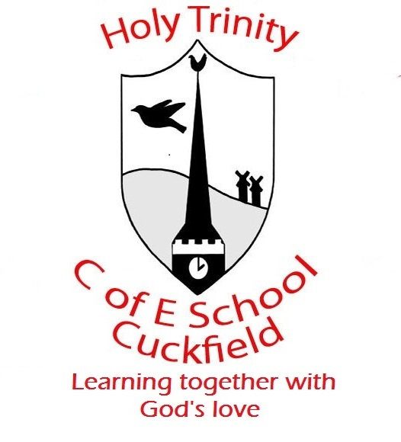 Update from Year 2 Week 3

Dear Parents / Carers Date: 24.1.20
We are thoroughly enjoying looking at traditional tales in English this half term. So far we have developed our descriptions skills for the characters and setting. Next week, we are looking at story mountains and how to write the middle part of our story. We are going to be considering different themes and how to resolve them. I am very impressed with their engagement with our story and the language that they have been using has been fantastic.
In maths we are coming to the end of our multiplication and division topic. It has been very successful and the children have been very confident with using the methods we have taught. Next week we are beginning to look at statistics which will involve tally charts and pictograms. I have also arranged for us to try a SATs paper to begin our training for SECRET AGENTS – as I said in the meeting please try to call it secret agent training rather than SATs to keep the magic alive! Gentle reminder to log onto times tables rockstars and MyMaths whenever you can.
Just to remind you all that we are going on our Lewes Castle trip on the 7th of Feb and the parent pay should be available. Also, in Elder next week we are welcoming a teaching student who will start on Monday. I will be telling the children today. She will be working with groups in the first week and slowly progressing to taking over some teaching with my support.
As ever, if you have any concerns or questions please do ask ☺

