Pupil premium strategy statement

This statement details our school’s use of pupil premium funding to help improve the attainment of our disadvantaged pupils.

It outlines our pupil premium strategy, how we intend to spend the funding in this academic year and the effect that last year’s spending of pupil premium had within our school.

School overview
Detail | Data
School name | Holy Trinity CE Primary
Number of pupils in school | 417
Proportion (%) of pupil premium eligible pupils | 9.4% 39 children
Academic year/years that our current pupil premium strategy plan covers (3 year plans are recommended) | 2024/2025 to 2026/2027
Date this statement was published | October 2024
Date on which it will be reviewed | October 2025
Statement authorised by | Ann MacGregor  Headteacher
Pupil premium lead | Emma Saunders  Assistant Headteacher
Governor / Trustee lead | Nick Bendall
Funding overview
Detail | Amount
Pupil premium funding allocation this academic year, based on January 2024 census (33 children) | £50,270  (£2570 LAC +£340 service +(£1480 x 32))
Pupil premium funding carried forward from previous years (enter £0 if not applicable) | £2108.50
Total budget for this academic year  If your school is an academy in a trust that pools this funding, state the amount available to your school this academic year | £52,378.50

Part A: Pupil premium strategy plan

Statement of intent
Our ultimate objectives for our disadvantaged pupils are:
- To narrow the attainment gap between disadvantaged and non-disadvantaged pupils.
- For all disadvantaged pupils in school to make or exceed nationally expected progress rates.
- To support our children’s mental health and wellbeing to enable them to access learning at an appropriate level.
Our current pupil premium strategy plan works towards achieving these objectives by:
- Ensuring that teaching and learning opportunities meet the needs of all the pupils.
- Ensuring that disadvantaged children have access to additional social and emotional support eg learning mentor, play therapist.
- Ensuring that disadvantaged children have access to individual and small group academic support.
The key principles of our strategy plan are:
- Ensuring all teaching is good or better thus ensuring that the quality of teaching experienced by all children is improved.
- The progress of disadvantaged pupils will be accelerated, moving children to at least age-related expectations and beyond.
- Additional learning support.
- Support payment for activities, educational visits and residentials. Ensuring children have first-hand experiences and cultural capital to use in their learning in the classroom.
- Behaviour support where appropriate.

Challenges

This details the key challenges to achievement that we have identified among our disadvantaged pupils.
Challenge number | Detail of challenge
1 | Mental health, social and emotional issues, accessing mental health support is becoming ever more challenging.
2 | Falling behind academically in reading, writing and maths. Internal assessments indicate that writing, including grammar, is a particular cause for concern.
3 | Attendance and punctuality.  For 2023-2024 attendance figures were: PP 91% and non PP 94%. Our assessments and observations indicate that absenteeism is negatively impacting disadvantaged pupils’ progress.
4 | Limited life experiences and home circumstances affect parent/carers’ ability to provide academic and social support. Our assessments and observations indicate that the education and wellbeing of many of our disadvantaged pupils have been impacted by this. These findings are supported by national studies.
5 | 46% of our disadvantaged children are also on our SEN register (18 children).
6 | Lack of access to technological equipment and the internet.

Intended outcomes
This explains the outcomes we are aiming for by the end of our current strategy plan, and how we will measure whether they have been achieved.
Intended outcome | Success criteria
For attendance of our PP children to be no lower than the attendance for non-PP children. For attendance to be ‘good’ compared to national attendance (96%). | - The school office will promptly call families who have an absent child without reason  - Extremely poor attendance (below 90%) will be challenged with communication from the headteacher and rigorously followed up.
PP children will make the same level of progress in reading, writing and maths as non PP children. | - Insight will show these children making good or better progress.(for PP children without SEN)  - PP children with SEN will make progress with other progress measured through their ILP  - PP children will develop a love of reading. They will be heard reading regularly by an adult at home and by adults in school.  - PP children’s attainment will be in line with or above those nationally (PP children with no SEN)
PP children will enjoy a wide range of enrichment opportunities | - A wide range of extra-curricular activities will be offered to tap into our children’s passions  - Pupil premium children will be offered discounted/paid for enrichment opportunities to include trips and visits, music lessons, residentials etc  - Children are able to learn a new skill or continue playing an instrument they had been learning.
PP children will feel happy and safe at school and engage with their learning. | - Pupil premium children will engage with the wider life at Holy Trinity Primary  - Children’s attendance will remain high (linked to 1) because they are happy coming to school  - Pupil voice surveys will report that PP children are happy and safe in school  - Pupil Premium champions (SLT) will meet with the children on a termly basis.

Activity in this academic year
This details how we intend to spend our pupil premium (and recovery premium funding) this academic year to address the challenges listed above.

Teaching (for example, CPD, recruitment and retention)
Budgeted cost: £37,200
Activity | Evidence that supports this approach | Challenge number(s) addressed
Dedicated use of staff meeting time to plan and discuss interventions in year group teams. | Evidence shows that if teachers plan interventions based on the Education Endowment Foundation’s research, this will ensure that the interventions are most effective. | 1,2,4,5
Contiune the use of Lexplore as a diagnostic reading tool. | EEF +5 months progress is made when using reading comprehension strategies. | 2,4,5
Ensuring enough time is given over to allow for staff professional development in order for Quality First Teaching to be evident in all classes during learning walks. This year, this will include a focus on questioning, retrieval and responsive coaching; led by Dave Cole from Shine Education. | Evidence shows that if teachers plan interventions/lessons based on EEF research, this will ensure that the interventions/lessons are most effective | 2,4,5
Ensuring ECTs have access to high quality CPD – Ambition programme. | Highly trained teachers are more able to deliver quality first teaching. | 2,4,5
Ensure that all staff delivering interventions are appropriately trained. Eg for 1st class@number, Read Write Inc, Lego Therapy | EEF + 4 months progress is made when small group tuition takes place. | 1,2,4,5
To enhance the provision for ‘Communication and Language’, to develop children’s speech and vocabulary (see SIP) | EEF +6 months oral language interventions  https://educationendowmentfoundation.org.uk/education-evidence/teaching-learning-toolkit/oral-language-interventions | 2,4,5
Writing training/workshops for teachers and LSAs, carried out by LH (inclusion manager and KFS (SEND teacher) | EEF +4 months small group interventions  https://educationendowmentfoundation.org.uk/education-evidence/teaching-learning-toolkit/small-group-tuition

Targeted academic support (for example, tutoring, one-to-one support structured interventions)
Budgeted cost: £9178.50
Activity | Evidence that supports this approach | Challenge number(s) addressed
Establish small group maths, reading and writing structured interventions for disadvantaged pupils falling behind age-related expectations.  - To ensure that children develop a fluid and fluent handwriting style, using a legible cursive script.  - To enable children to learn their spellings in a multi-sensory way, which will help with retention and application to their written work.  - To improve the progress and attainment of children’s writing across year groups. To encourage children to spot errors in their writing and improve the quality of what they produce.  - To improve the progress and attainment of children’s mathematical skills. To recognise key areas which children are finding more challenging and support them to over-learn strategies taught so they are confident to use these strategies independently and apply them to independent work.  - To encourage children to infer and deduce from texts they have read. They will be encouraged to locate answers within the text, but also look at the language of the book and answer ‘why’ questions and deepen their understanding.  - To improve oracy and language, including incorporating more talk and drama into lessons. | EEF:  Giving quality feedback results in +8 months progress.  Reading comprehension strategies result in +5 months progress.  Mastery Learning results in +5 months progress.  Collaborative learning results in +5 months progress.  Small group tuition results in +4 months progress.  https://d2tic4wvo1iusb.cloudfront.net/eef-guidance-reports/literacy-ks2/KS2_Literacy_Guidance_2017.pdf  https://educationendowmentfoundation.org.uk/public/files/Publications/Maths/KS2_KS3_Maths_Guidance_2017.pdf  Tuition targeted at specific needs and knowledge gaps can be an effective method to support low attaining pupils or those falling behind, both one-to-one:  One to one tuition | EEF (educationendowmentfoundation.org.uk)  And in small groups:  Small group tuition | Toolkit Strand | Education Endowment Foundation | EEF  Oral language interventions +6 months  https://educationendowmentfoundation.org.uk/education-evidence/teaching-learning-toolkit/oral-language-interventions | 2,4,5,6

Wider strategies (for example, related to attendance, behaviour, wellbeing)
Budgeted cost: £6,000
Activity | Evidence that supports this approach | Challenge number(s) addressed
Social and emotional support groups  - To support children with their friendship groups, develop their resilience and interaction with their peers.  - To improve their communication skills and improve their focus in the afternoons.  - To encourage good mental health and well being. | EEF:  Social and emotional learning +4 months progress.  There is extensive evidence associating childhood social and emotional skills with improved outcomes at school and in later life (e.g., improved academic performance, attitudes, behaviour and relationships with peers):  https://educationendowmentfoundation.org.uk/public/files/Publications/SEL/EEF_Social_and_Emotional_Learning.pdf | 1,4
Pay for clubs, trips, residentials.  - To ensure pupils are included as part of their year group.  - To build pupils’ self-esteem and independence.  - To allow pupils to have additional opportunities and pursue their interests.  - To improve their level of engagement with peer group.  - To improve pupils’ well-being. | EEF:  Children attending Outdoor Adventure learning make progress of +4 months. | 1,3,4,
Homework club – using school ICT suite to complete eg Mymaths homework if children do not have the access at home. | EEF:  Children receiving homework make progress of +2 months. | 6
Attendance:  - The school office will promptly call families who have an absent child without reason  - Extremely poor attendance (below 90%) will be challenged with communication from the headteacher | All research indicates that children who regularly attend school make better progress and achieve better outcomes.  https://www.gov.uk/government/publications/school-attendance/framework-for-securing-full-attendance-actions-for-schools-and-local-authorities | 3

Total budgeted cost: £52,378.50

Part B: Review of outcomes in the previous academic year

Pupil premium strategy outcomes
This details the impact that our pupil premium activity had on pupils in the 2023 to 2024 academic year.
Year 6 SATs data analysis 2024

PP Children: 4 | EXS+ | GDS
Reading | 75%( 3 children) | 0%
Writing | 0% (0 children) | 0%
Maths | 25% ( 1 child) | 0%

It is very difficult to make statistically sound judgements from this Year 6 data as there are so few Pupil premium children. Three of these children were also on the SEND register. The fourth child joined us at Easter and therefore only had 2 months at our school before taking the SATs tests. However, from assessments and observations, we have identified that oracy and writing are areas to focus on for our disadvantaged (and SEND) children, as detailed in this strategy.

The first table below details our teacher assessment data for each year group for our disadvantaged children. We are pleased with the progress our disadvantaged children have made. All progress (with the exception of Year 3 disadvantaged reading) is expected or better.

However, although progress is generally expected or better, the percentages of children who are ’on track or higher’ are still below those of non PP children (see second chart below). As a result, in order to address this, we have created this new 3 year Pupil Premium strategy to address the challenges as detailed on page 3.

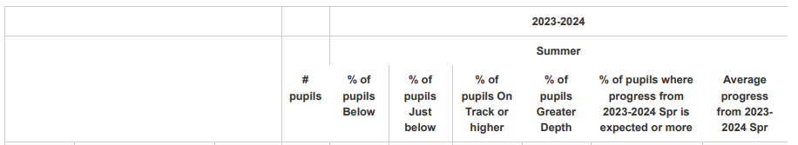
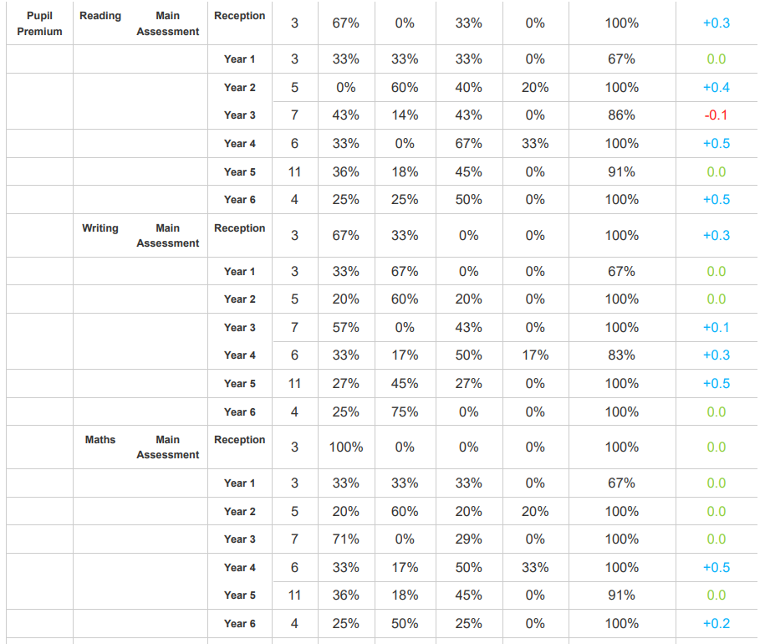

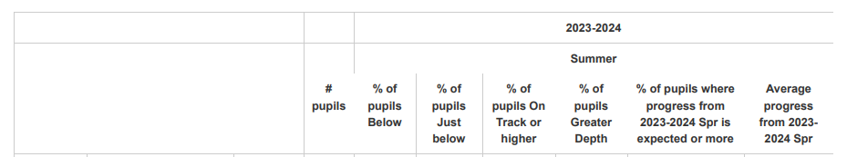
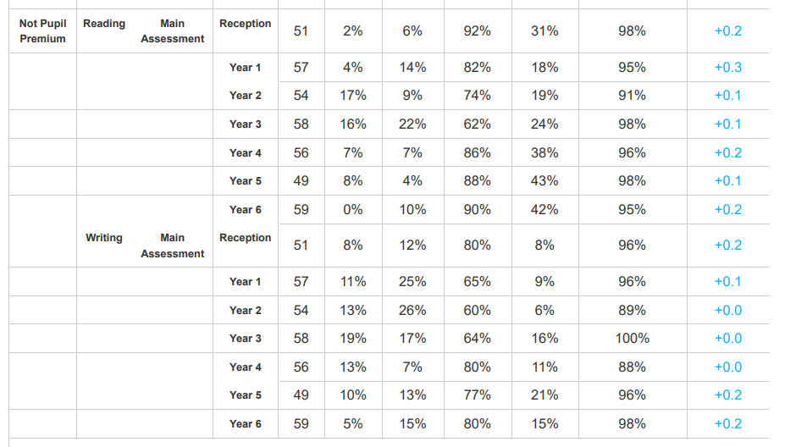
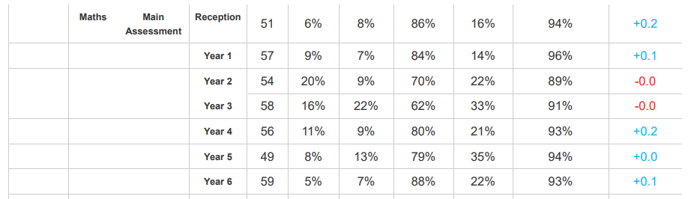

Externally provided programmes
Please include the names of any non-DfE programmes that you purchased in the previous academic year. This will help the Department for Education identify which ones are popular in England
Programme | Provider
Lexplore | Lexplore Analytics Ltd
White Rose | TrinityMAT

