

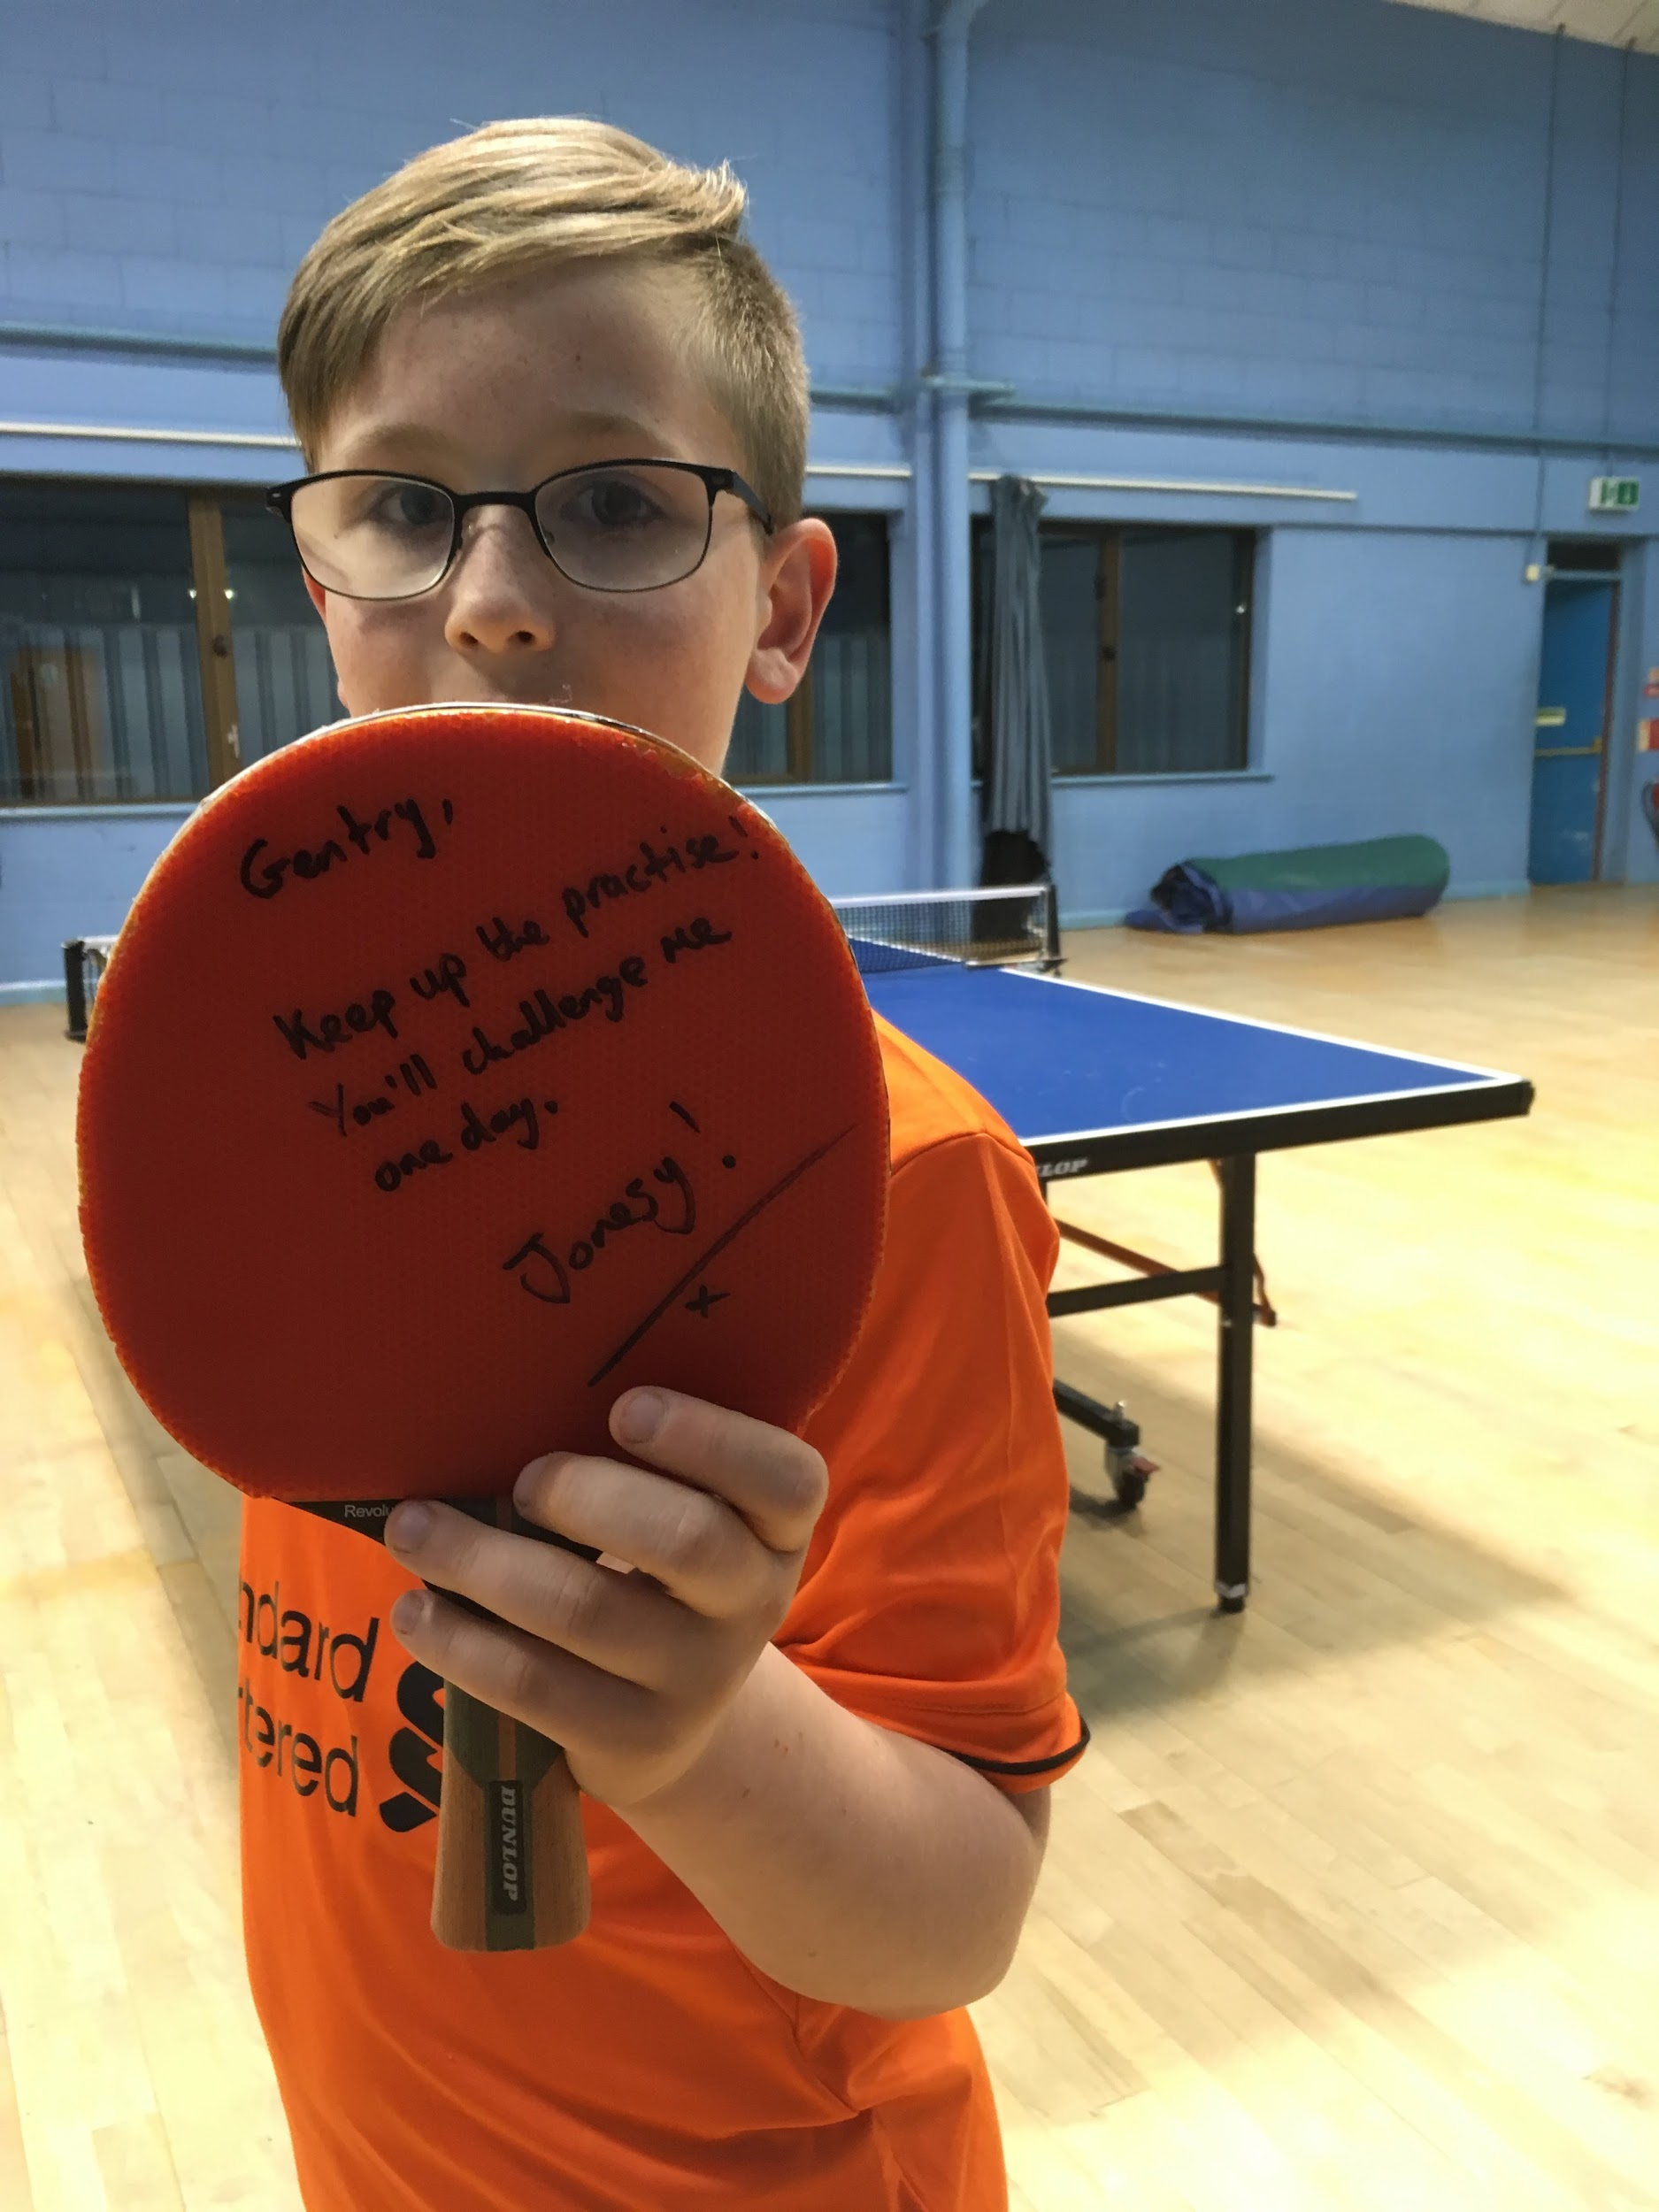 

***PROMOTING SPORT FOR ALL***

***prostarsportscamps.weebly.com***

Dear Parent/Guardian

***October 2024***

I am writing to inform you of an exciting **Multi sports course** that will be running during the Xmas holiday at **Warden Park Academy in Cuckfield** . Pro star Sports will run the course in conjunction with Mr Gentry, Mr Turner and Mr Alderman. Each day students will have 8 to 12 sessions of sports ranging from football, netball, dodgeball, rounders, badminton, table tennis, handball, basketball cricket, frisbee, stoolball, rugby, athletics, sleeping lions, tug of war and more. There will be 2 options for each session some will be inside others outside.

The course will run on  **Monday 23rd December,** *The course will be extremely popular and there are only* ***10/15 places*** *available per age group. Therefore places will be allocated on a first come, first served basis.*

All students will have the opportunity to experience first class coaching delivered by qualified coaches and PE teachers. The course will be designed to maximise the potential of each child and it will be an excellent opportunity for your child to improve existing skills in a wide range of sports, improve fitness and make new friends. Boys and girls from Years 1, 2, 3, 4, 5, 6, 7, 8 and 9 are welcome.



Your child will be placed in a group that matches his/her age and skill level. This can be changed if required.

The day will start with registration between **9.15am - 9.30am with the day starting at 9.45am**. The morning and afternoon will consist of fun games, coaching, competitions and the skill drill session and conditioned games. No food or drink will be available, therefore packed lunches and drinks are required. The day will finish at **3.30pm** and children will be dismissed when a parent or guardian collects them from Warden Park. **HALF DAY** option available 9.30-12.30 or 12.30-3.30 at £11, please book the day as normal and in comments add half day am or pm.

The cost of the course is  **£22 per day**. Places will be limited, therefore first come first served.

**BOOK NOW**

[CLICK HERE TO BOOK](https://docs.google.com/forms/d/1tkwDNLQTI1VpJNbe08kv75_gWYfTv0SpsRYvs_tSbrQ/edit)

**Bank Transfer:**

| Bank Name | Santander | Bank Account Sort Code | 09-01-27 |
| --- | --- | --- | --- |
| Bank Account Name | J Cailes-Gentry | Bank Account Number | 10158573 |
| Booking Reference | Child’s surname and reference code MS e.g., **Gentry MSX** | | |

Yours faithfully

**J Gentry**

J S Gentry

PE Teacher, Director of PE and Sport, Director of PSS - Est 2002

**Mr Gentry - 07900810738**

[jamesprostarsports@gmail.com](mailto:jamesprostarsports@gmail.com)

-------------------------------------------------------------------------------------------------------------------------------------