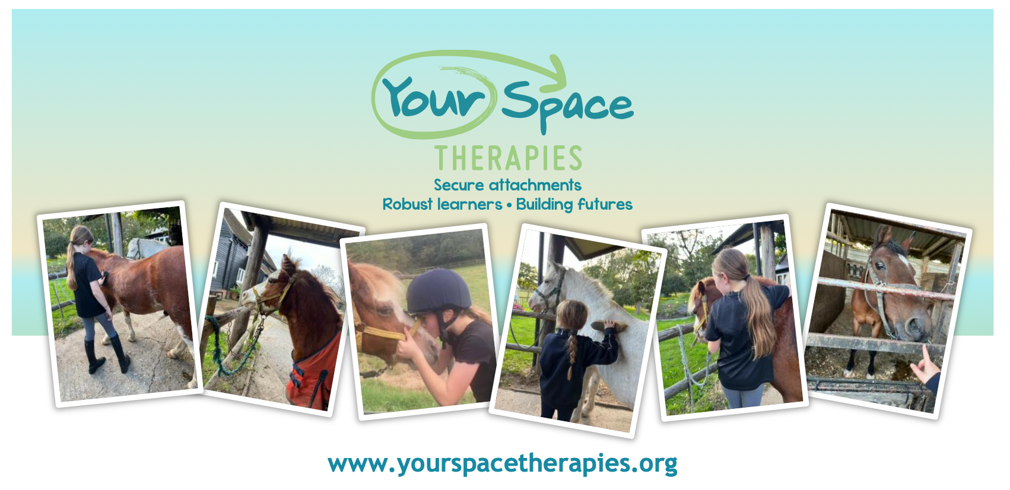
Explore Calm, Connection, and Confidence with Our Gentle Ponies!
🌼 May Half Term Mindfulness Pony Day for Kids! 🌼
Date: Friday 30th May 2025
Time: 9.30am- 2.30pm
Location: Ponies ‘n’ Kids, Eaton Thorne Stables, Woodmancote, Nr Henfield, W.Sussex, BN5 9BH
Join us for a magical day designed especially for children ages 5-11! Dive into a world of peace, friendship, and mindfulness, all while experiencing the calming presence of our adorable ponies.
✨ What to Expect:
💖 Mindfulness Time with Ponies: Learn calming techniques and emotional regulation skills while spending quality time with our gentle ponies.
🦄 Pony Care: Discover the joys of caring for ponies through grooming, feeding, and building a bond.
🏇 Riding and Mounted Games: Experience the joy of pony rides and engage in fun, team-based games that promote confidence and cooperation.
🐴 Mindful Nature Art: Unleash your creativity with activities that inspire observation and connection with the natural world.
🌳 Connect with Nature: Immerse yourself in the tranquillity of our beautiful, quiet stables and serene surroundings.
🎉 Make New Friends: Build connections and friendships with other children in a supportive, nurturing environment.
Spaces are limited to 12 children! Email now to ensure your spot.
Contact: bookings@yourspacetherapies.org
Cost: £110 plus VAT

Join us for an unforgettable experience that combines mindfulness and pony magic! 🐴💖

